In alignment with Saskatchewan Ministry of Education direction, and to support student learning and mental health and well being, Chinook School Division has introduced Administrative Procedure 139 - Use of Smartphones/Personal Electronic Devices. Read the details: <https://docs.google.com/document/d/1C25FvFk2n6bWe8fD8u5ZD_5xkQ1lwYEqABE8tTy6kmk/view#heading=h.fy3i3w2u1bvo>.

PREKINDERGARTEN-GRADE 8

Smartphones/personal electronic devices shall not be used by prekindergarten to grade 8 students during instructional time. School administration may also limit usage outside of instructional time, including recess and the noon hour.

GRADES 9-12

As smartphones can be a powerful complement to learning with responsible use and digital citizenship, they may be permitted during instruction for grades 9- students when supported by a classroom management plan and approved by the principal. Gr 9-12 students will be permitted to use smartphones/personal electronic devices during breaks and during the lunch hour, and must adhere to all guidelines during these times.

A growing body of research points to problematic side effects related to distraction, loss of focus and potential addiction to smartphones. There are several benefits to students and their learning environment when the use of personal electronic devices is limited.

[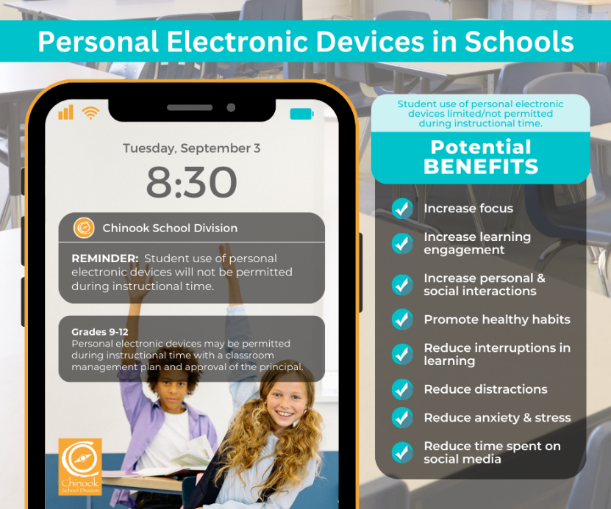](https://drive.google.com/file/d/1643Knlof6WtKoBLLw8nSyrS5r5aKqwih/view?usp=sharing)

Optional: [Link to content on the division website](https://www.chinooksd.ca/Pages/newsitem.aspx?ItemID=466&ListID=71a50195-e7f6-411b-8ec2-eab81a591621&TemplateID=Announcement_Item#/=)